**Week 8 - Lab A**

**Problem 1: Tuple Manipulation**

Write a Python program that does the following:

1. Create a tuple named prime_numbers containing the first 5 prime numbers.
2. Print the second element in the tuple.
3. Attempt to change the first element of the tuple and observe the error that occurs (write a comment explaining what happens).
4. Define a function get_student_details() that prompts the user to enter their first_name, last_name, and student_id. The function should return these details as a tuple.
5. Call the get_student_details() function and print the returned tuple.

**Example:**

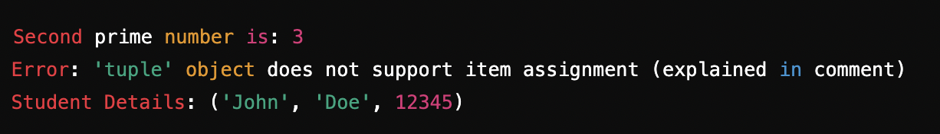Paste your source code below:

prime_numbers = (2, 3, 5, 7, 11)

print("Second prime number is:", prime_numbers[1])

try:

prime_numbers[0] = 1 # This will fail because the elements inside a tuple are immutable. Tuple must be changed as a whole.

except:

print("Error: 'tuple' object does not support item assignment (explained in comment)")

def get_student_details():

first_name = input("First Name: ")

last_name = input("Last Name: ")

student_id = int(input("Student ID: "))

return (first_name, last_name, student_id)

print(f"Student Details: {get_student_details()}")

Paste the Screenshot of your output below:

Second prime number is: 3

Error: 'tuple' object does not support item assignment (explained in comment)

First Name: John

Last Name: Doe

Student ID: 12345

Student Details: ('John', 'Doe', 12345)

### **Problem 2: Medal Count Table**

Write a Python program that manages Olympic medal counts using a table of lists inside a list:

1. Create a list of lists named medal_table where each inner list contains:
   * The name of the country (as a string),
   * The number of gold medals (as an integer),
   * The number of silver medals (as an integer),
   * The number of bronze medals (as an integer).
2. Example: medal_table = [["USA", 3, 2, 1], ["China", 2, 1, 0], ["Japan", 1, 0, 1]]
3. Define a function total_medals() that takes this table and a country index as input and returns the total number of medals (sum of gold, silver, and bronze) for that country.
4. Print out the total medals for a specific country by calling total_medals().

**Example:**



Paste your source code below:

medal_table = [

["USA", 3, 2, 1],

["China", 2, 1, 0],

["Japan", 1, 0, 1],

]

def total_medals(table, index):

return sum(table[index][1:])

print(f"Total medals for USA:", total_medals(medal_table, 0))

print(f"Total medals for China:", total_medals(medal_table, 1))

Paste the Screenshot of your output below:

Total medals for USA: 6

Total medals for China: 3